**MongoDB Case Study-1**

**Name: PRIYESHWAR M D**

**Mail:** [**priyesh2664@gmail.com**](mailto:priyesh2664@gmail.com)

**Find all the information about each products**

db.product.find()

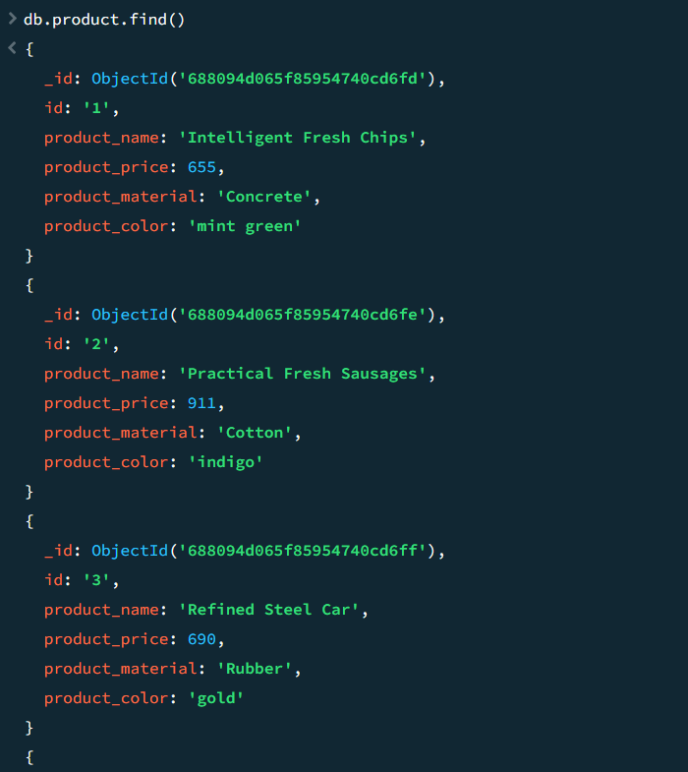

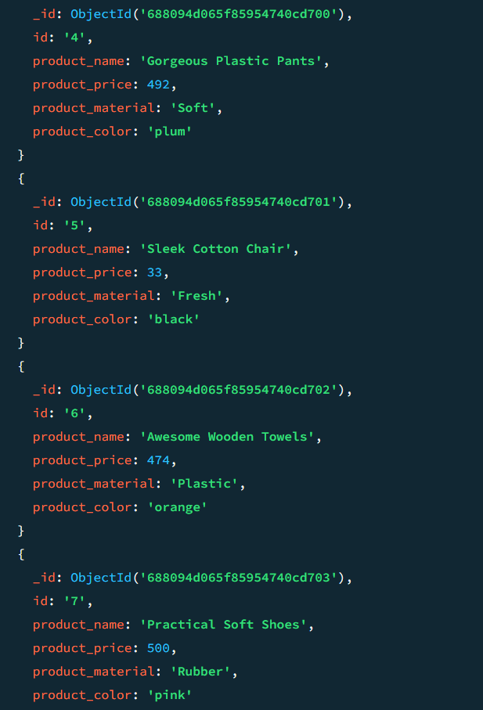

**Find the product price which are between 400 to 800**

db.product.find({product_price:{$gt:400,$lt:800}},{})

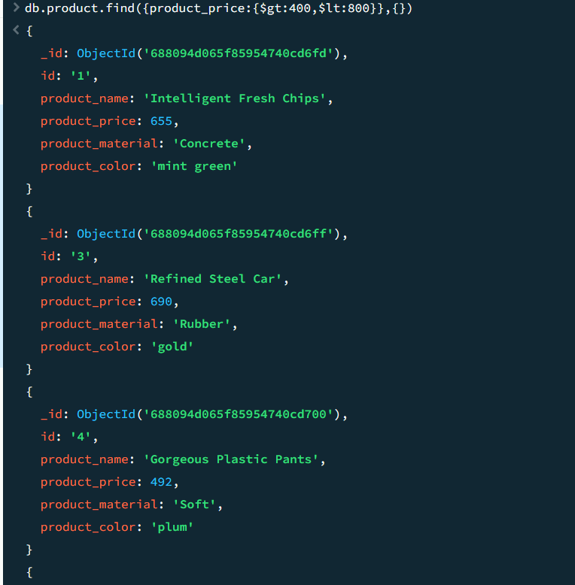

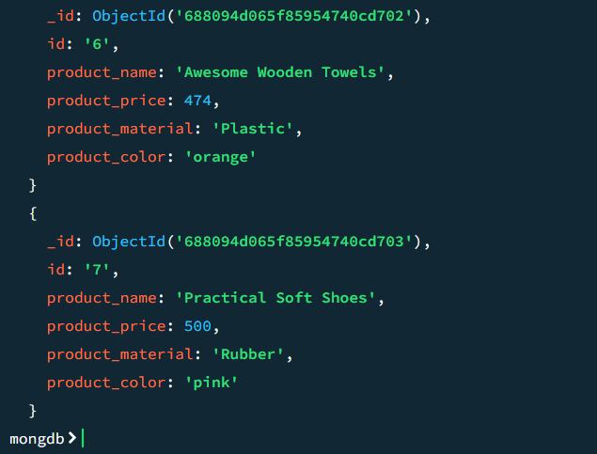

**Find the product price which are not between 400 to 600**

db.product.find({product_price:{$not:{$gt:400,$lt:600}}},{})

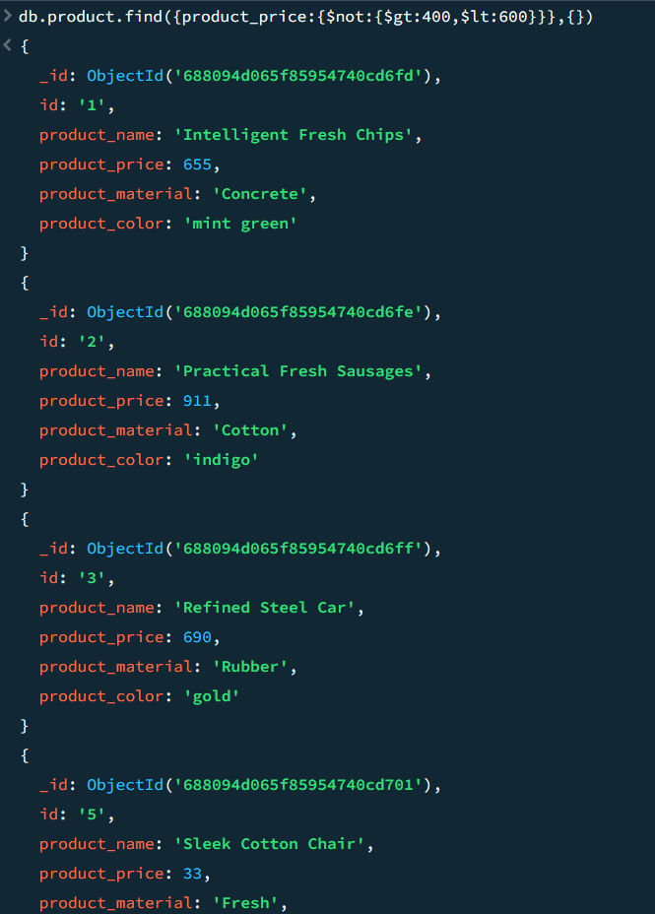

**List the four product which are grater than 500 in price**

db.product.find({product_price:{$gt:500}},{}).limit(4)

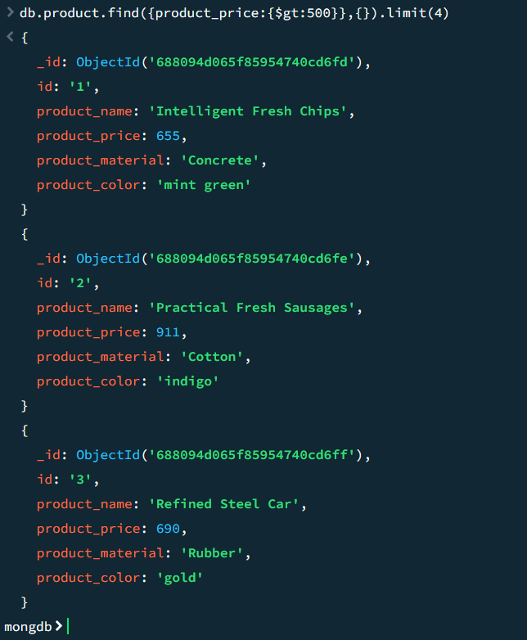

**Find the product name and product material of each products**

db.product.find({},{product_name:1,product_material:1,_id:0})

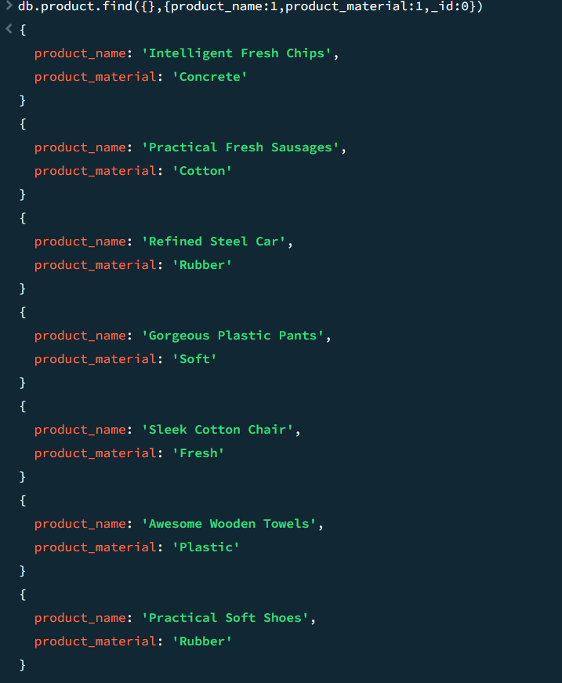

**Find the product with a row id of 10**

db.product.find({id:'10'},{})

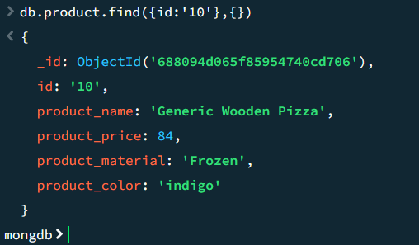

**Find only the product name and product material**

db.product.find({},{product_name:1,product_material:1,_id:0})

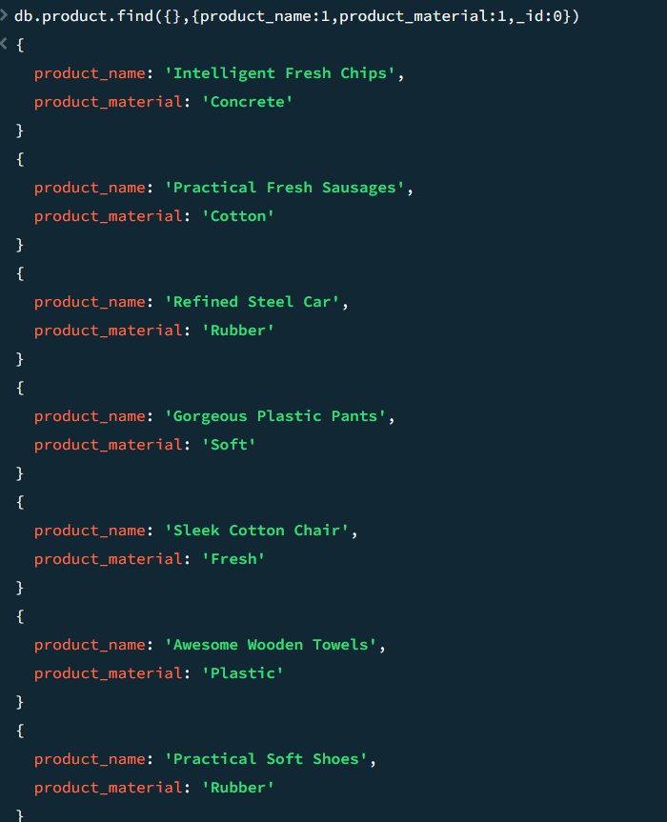

**Find all products which contain the value of soft in product material**

db.product.find({product_material:'Soft'},{})

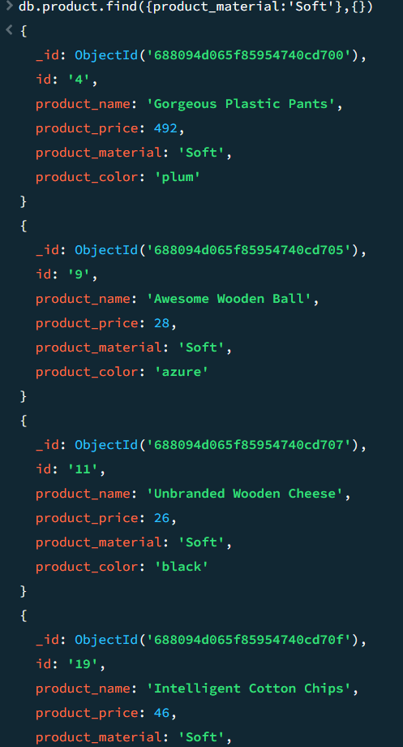

**Find products which contain product color indigo and product price 492.00**

db.product.find({product_color:'indigo',product_price:492},{})

